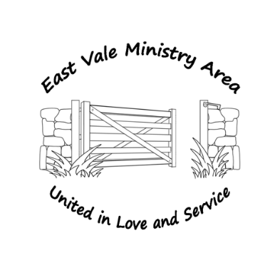
St Cadoc’s Church Llancarfan
Dear Parishioner

The Church is described in Scripture as being like a body with many parts, each having a unique role and depending on the other members.
The Church is a community of people, but we worship and meet in buildings which are important to the whole community. These need ongoing attention and maintenance as does our worship and fellowship. Large and complex tasks have to be undertaken by professionals, however there are many other aspects of Church life that can and should be done from within the ‘Body’. This survey is an invitation to everyone to consider how you may offer time or skills to our Church.

So, if you are someone who is new to the Church or this area, please don’t be shy; you will not be ‘signing your life away’ by filling in this form! You’ll simply be expressing a general interest or willingness to support the Church. If you are a long-standing worshipper at our Church this may be an opportunity to flag up a skill or an interest that the rest of the Church Community doesn’t know about. “I already do ...and...” if this is you, then we just want to say “thank you” and please continue.

We have deliberately avoided offering a tick list, instead we have adopted 2 broad sections which we feel cover much of the life of the Church. Inevitably the categories will overlap, but don’t be concerned about this, simply outline how you think you might be able to help. Don’t forget this may well be a chance for you to have a go at something you’ve never tried before, you may even discover a latent talent.

Please return to either Sue Taylor or Sam Smith your Church Coordinators

My name is:-

My best contact details are:-

1 - Supporting the life and fellowship of our Churches and Parish, for example, would you be interested in: reading/leading Church intercessions, offering a lift to Church to a fellow parishioner (e.g., elderly), taking part or interested in supporting activities for children, youth groups and young families?

2 - Providing practical assistance and offering a spare pair of hands, for example, are you good at DIY (please tell us the type of DIY skills), do you sing or play a musical instrument, or are you keen on flower arranging/gardening, could you help at one of our social events?

